Executioon document:

1. Create a new connect

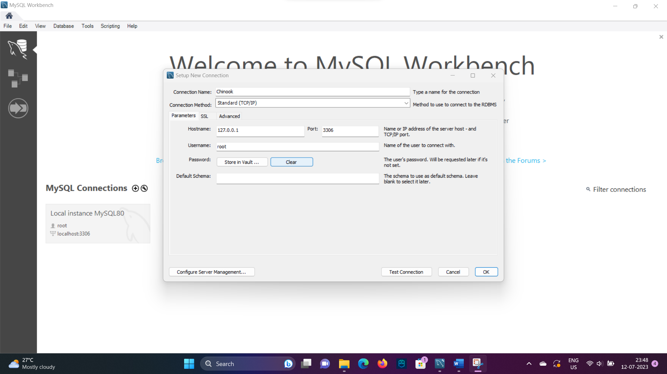

1. New connection created successfully

1. Creating tables
2. 

